The electronics of the robot are broken up into two major subsystems, the motherboard and the debug panel. The motherboard was designed to contain the auxiliary electronics and signal conditioning components needed for the robot. The debug panel contains all necessary electronics to display battery levels and other statuses of the robot.

The motherboard contains the signal conditioning for each of the pneumatics cylinders. Each pneumatic cylinder is controlled by a signal analog direct current voltage. However, the signal driving this analog voltage is a pulse-width-modulated (PWM) output on the microcontroller. To convert a PWM into an analog signal an active low pass filter is used. After the low pass filter an opto-isolator is used to separate the microcontroller circuit from the pneumatic actuator circuit. An opto-isolator works by converting an electrical signal into an optical signal by using a diode. The optical signal is recaptures within the device and output onto another circuit as a current signal. At the output of the opto-isolator a trans-impedance amplifier is used to convert the output current signal to a voltage signal for the solenoid. To handle the feedback signal from the pneumatic actuator another opto-isolator is used to separate the two power circuits then the signal is amplified before being read by the microcontroller’s built in analog to digital converters (ADCs).

The debug panel subsystem contains a physical panel with light emitting diodes (LED) and connections for banana plug cables. The LEDs are used to show battery levels and the status of the robot. The banana plug connectors are used to interface to Milwaukee School of Engineering’s test equipment in the labs. Banana plugs are used because they are standard on test equipment. A USB slot is also included on the debug panel to assist in programming the microcontroller while leaving it in the robot.

The control algorithms are software implementations on the microcontroller. The software was not written by the team, but is instead code generated from Mathwork’s Simulink models. The control algorithm a proportional integral derivative controller using one input signal. This input signal is the position setpoint minus the feedback signal from the cylinder. Figure 1 shows the Simulink model for a whole leg using an upper and lower cylinder PID.

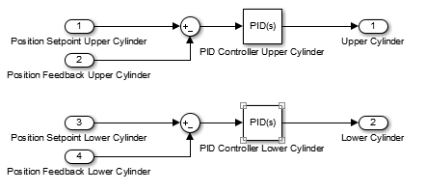

Figure PID Model of a Leg